Hello,
My name is Julia, I am 14 and I live in Saint Petersburg. It is a beautiful city. There are many interesting and exciting places. For example, the Hermitage, Isaak Cathedral, St. Peter and Paul`s Cathedral. My favourite one is the Hermitage.
I am a pupil of the 9th form of gymnasium 168. It is the only one in St. Petersburg facing the Nevsky Prospect. It is situated not far from the monument to Saint Patron of Petersburg Alexander Nevsky. And in our school there are many modern facilities.
I live only with my mother because she and my father are divorced. My mother is a very nice and kind woman. She always gives me good advice in different situations. She is a director of the supermarket. She is very clever and I love spending time with her. I love my mother very much. I like to go to the cinema, to the theatre and to the cafés with her.
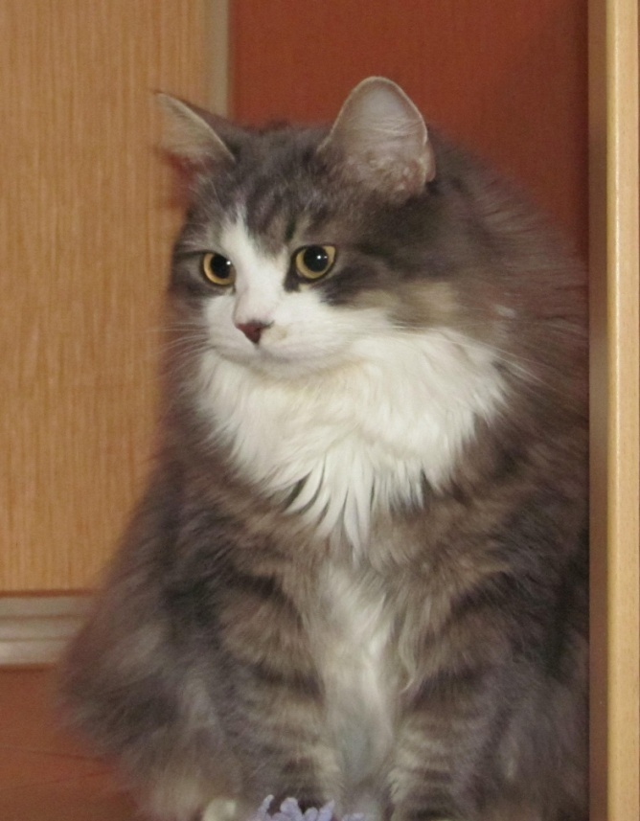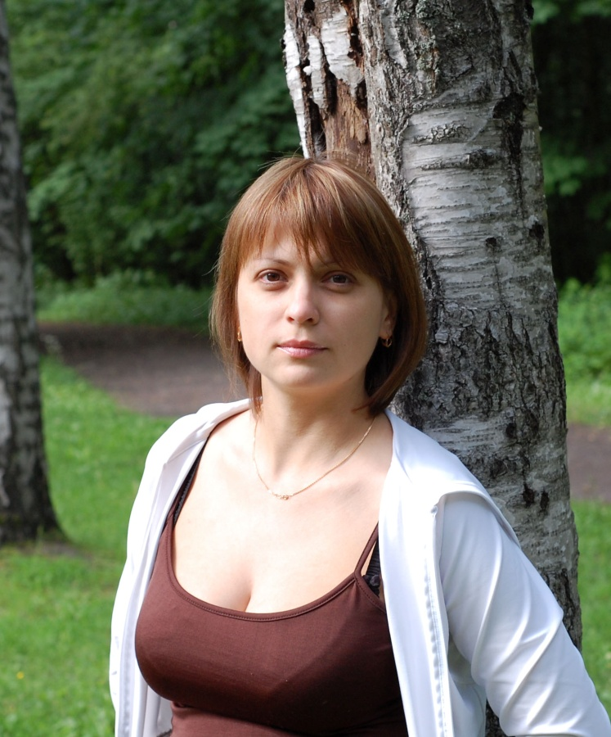

I have a cat. Her name is Lesya. She is grey and white. She likes to play with me and with balls.
I also have many friends. They often support me and spend free time with me. I love them.
So, I love to meet new people and will be glad to meet a new friend.
Best wishes,
Julia

