Hello, I'm Vika. I'm 15.I am from Russia, I live in Sant-Petersburg, in Stahanovzev Street with my family.
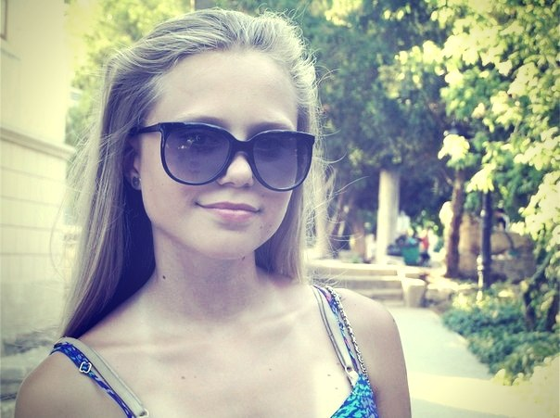
I can say our family is very big. It consists of my mother, father, sister, brother, me and our cat. We love each other very much. My mother is Oksana, she is my best friend and she can give me good advice. My mother is a clever and kind woman. My father is Gena. He is a very funny man. He gives me a lot of positive emotions. My brother is Taras. I'm an elder sister for him. I help him in every situation. I have the eldest sister, she is Sasha. She is 22 and she doesn’t live with us. She lives with her boyfriend.
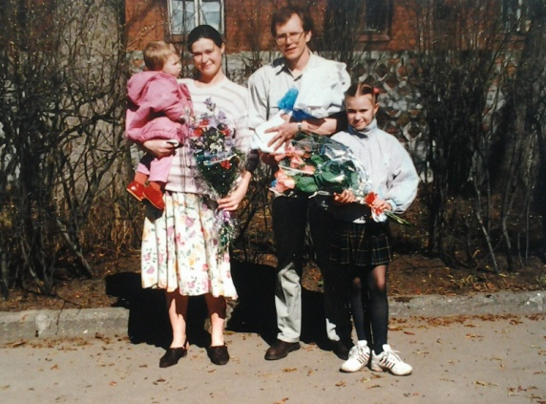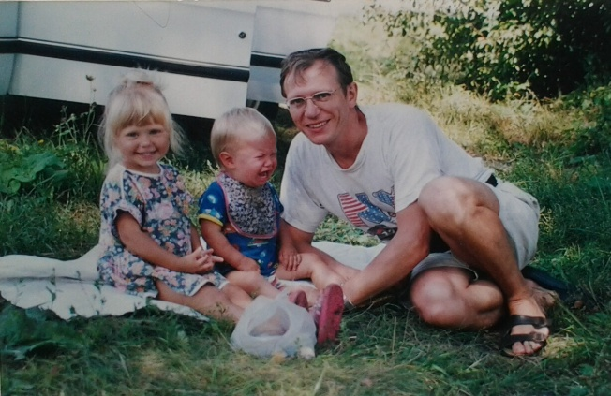
I have a pet. It is a cat. It is Nixon. It is a black cat with yellow eyes. It is very nice. My family loves it very much.
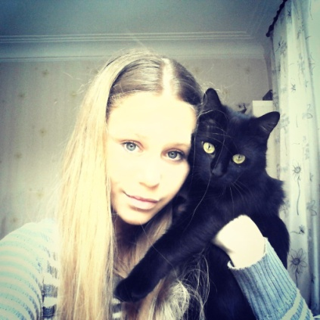
I can say that I have many friends. Together with them we are going to concerts and to museums. We also go to the cinema. We like soap operas and comedies. I and my friends always go to the park. It is our favorite place. I like to spend my time together with them in my town. I like my city because it is very beautiful and interesting. Sant-Petersburg is a cultural city. It has a lot of cathedrals and monuments. My favourite cathedral is St. Isaac's Cathedral because from the top of the cathedral we can see the whole Saint-Petersburg.
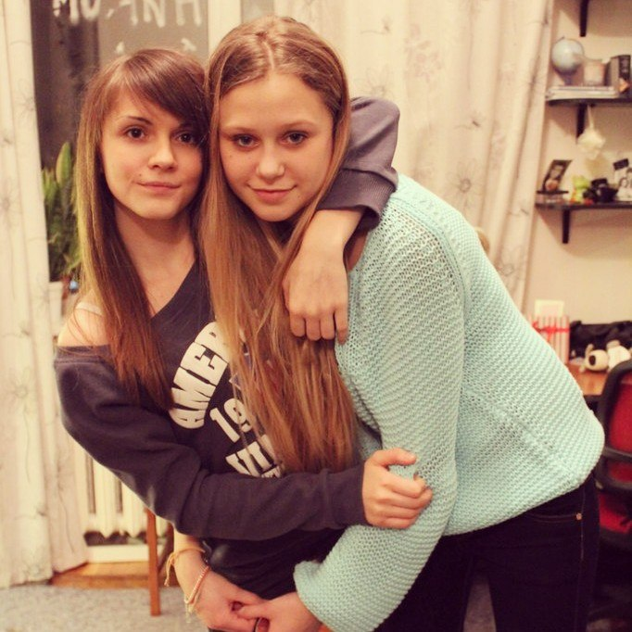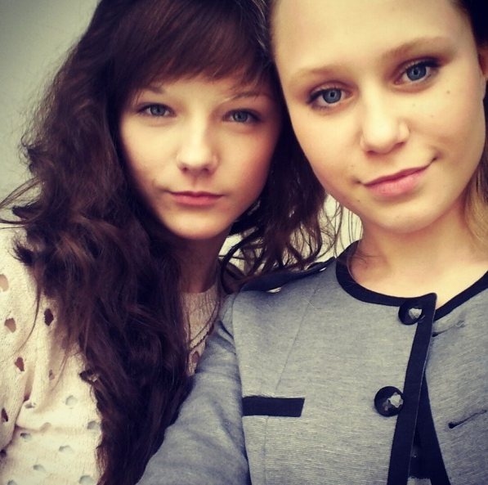
I have many hobbies. For example: music, photo, pictures, but my favourite hobby is dancing. I started to dance when I was 5. I take part in competitions with my dance group. It gives me a lot of pleasure. I like it.
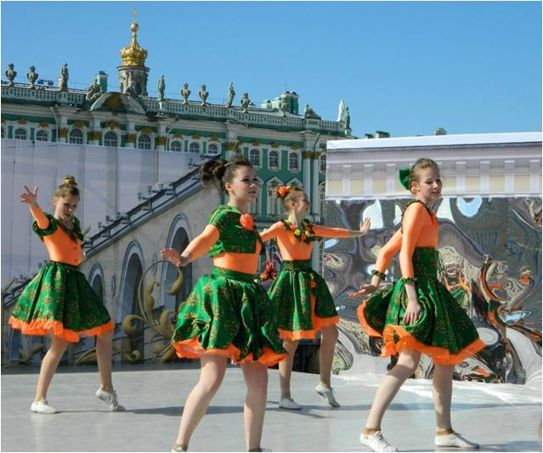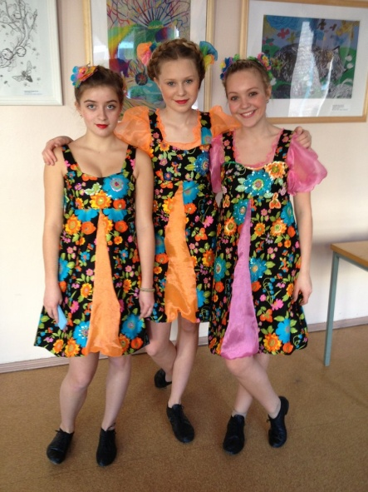

I also like to read books. My favourite authors are Suzanne Collins, Aleksandr Pushkin and Reshad Nuri Guntekin. Their books are fantasy, classical ones and novels.
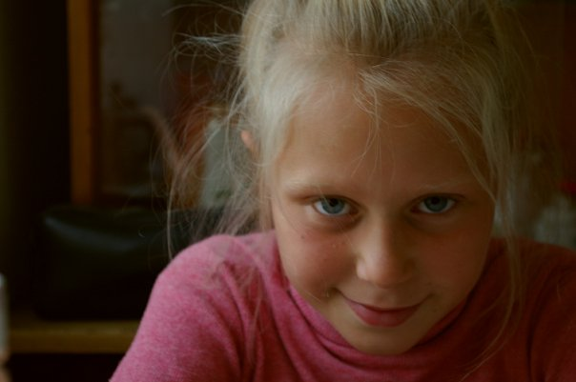
Every summer I and my family go to our grandparents. They are Tamara and Peter. They live near the Azov Sea. The climate is very warm there. I have a lot of relatives and I miss them.
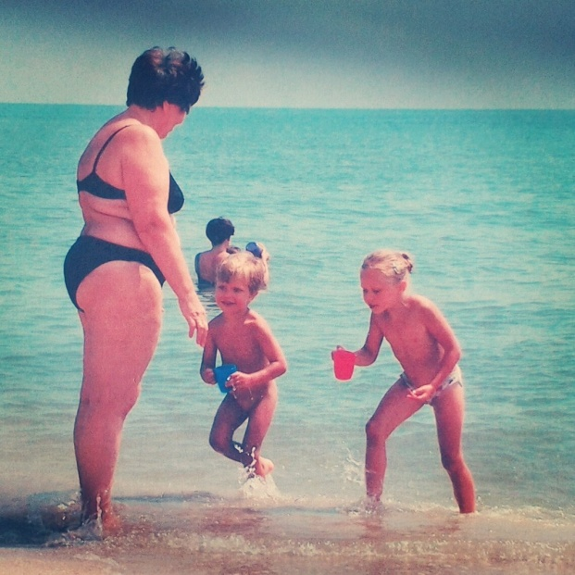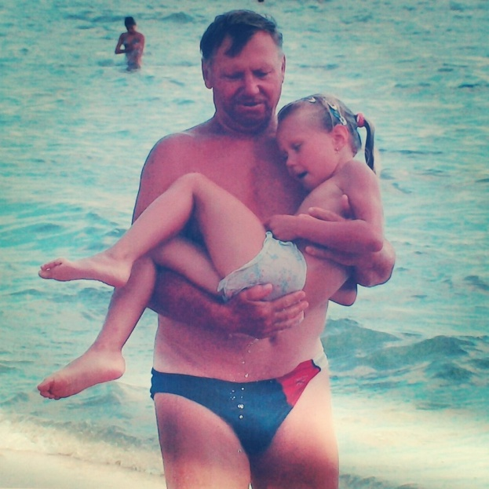
I will be glad to meet you! Best wishes, Vika!
