Hello,
I’m very glad to write you this letter. I feel nervous a bit. It’s my first letter to a foreign country.
My name is Ivan Bakanov and this is my photo: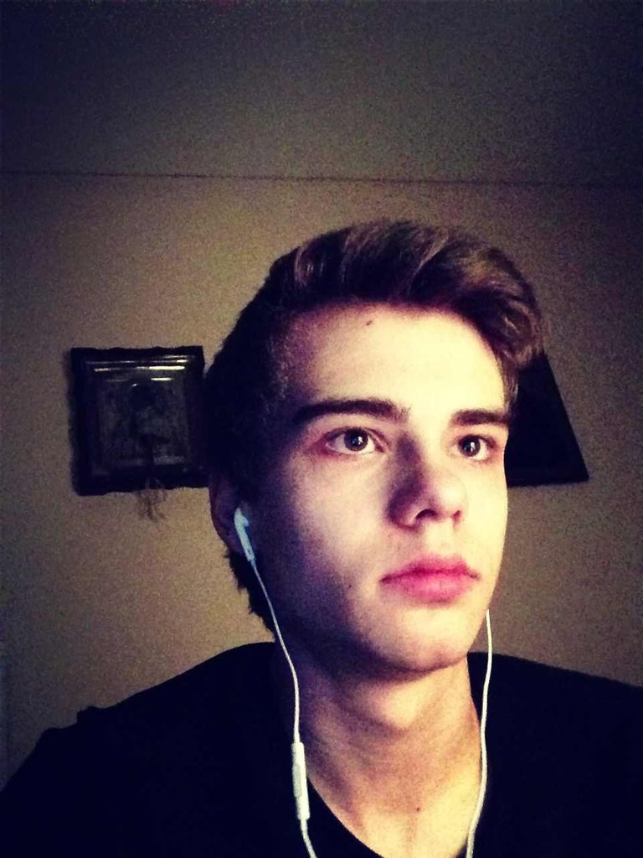
I’m sixteen years old. I live in Saint-Petersburg. I like my city very much. As you know it received the poetic name of “Northern Venice” for its remarkable architectural ensembles. At present St. Petersburg is one of the most beautiful cities in the world. Here we have many places of interest. For example: Palace Square. It is the main square of St. Petersburg. It’s the center of the city. The ensemble of Palace Square consists of Winter Palace, General Headquarters building, Alexander Column and the Guard Headquarters.
I like my family very much. My parents are the best. They do everything to encourage me when I’m upset or have some troubles. We always celebrate all holidays together. Sometimes we go abroad and have fun together. I love my parents very much and they love me too.
Also I have many friends who say that I am a friendly person who loves to communicate. We have lots of common interests. That’s why we like spending our free time together. We always go to the cinemas, clubs or café. Sometimes we do some sports together. For example: we play football or basketball in summer and in winter we usually do some skiing and snowboarding together. I’m fond of sports.
Actually I have an active lifestyle. I do morning exercises and run sometimes. I also go to the gym. I like swimming but I don’t have enough time to go to the swimming pool. But in summer I go to my dacha where the huge lake is situated near my country house. So I practise swimming a lot there.
I‘m very fond of music. I like alternative rock. I prefer such groups as Linkin Park, Thirty Seconds to Mars, System of a Down, Elect the Dead and many others. I also like trance music. My favorite DJ is Armin Van Buuren.
In future I would like to be a computer programmer because I know Maths, English and programming very well.
Now I must stop writing because I must do my homework.
With best wishes,
Bakanov Ivan.

