Hello,
Firstly, I’d like to introduce myself. My name is Polina. I’m 14 years old. I live in St. Petersburg, one of the most beautiful cities of the world. My family isn’t so big. It consists of my mom, my dad, my brother and me. Also, I have a puppy. His name is Sherik. He is the cutiest creature in the world. I love him so much. However, I’m a student of the 9th grade of 168 Gymnasium of the world. My hobbies are tennis and photography. I really enjoy spending time on it.
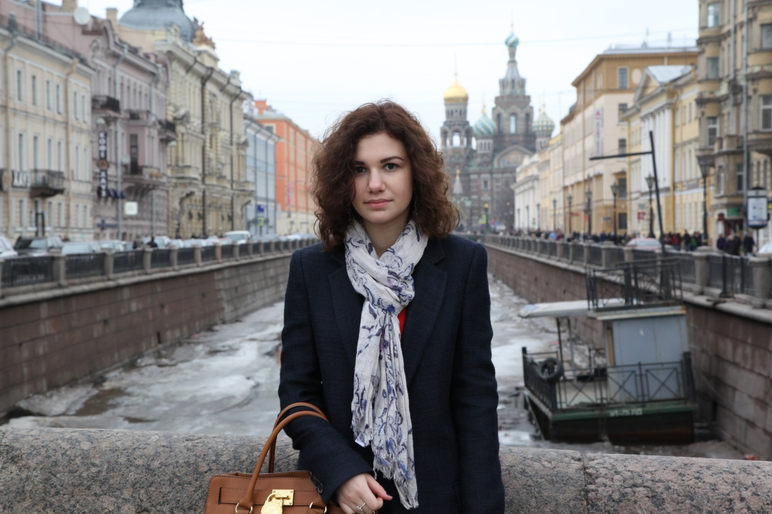
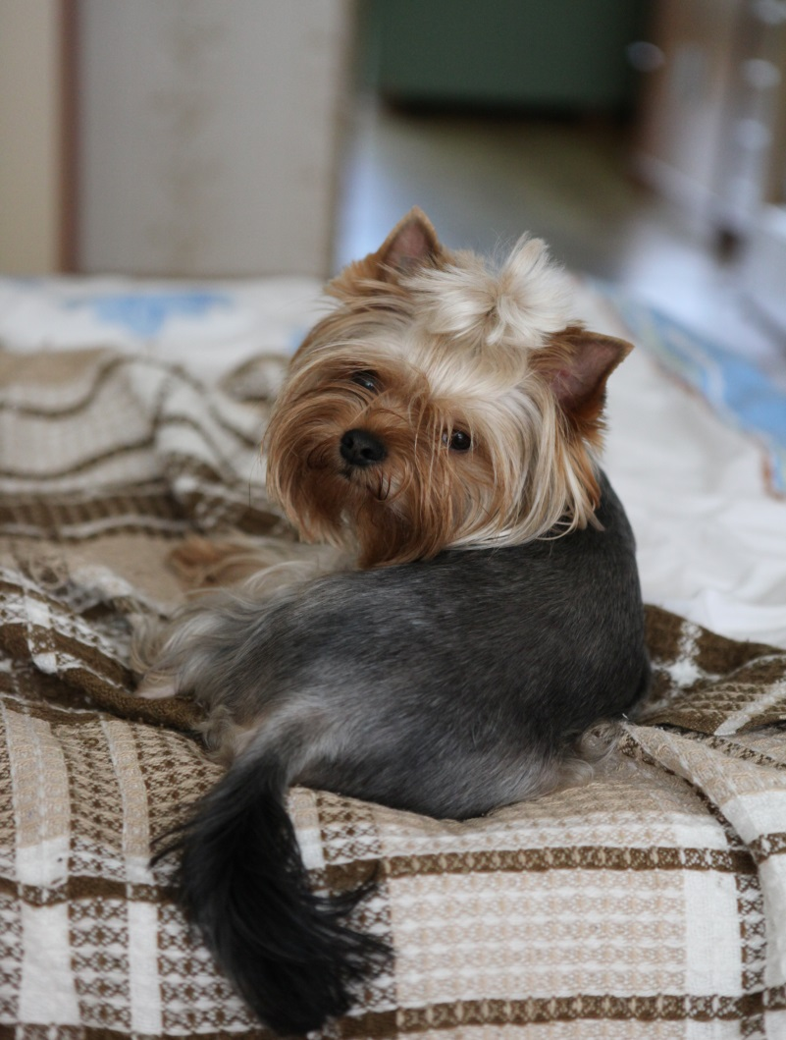
Next, I’d like to tell about what I do in my spare time. Of course, I spend it on my hobbies, but mostly I prefer going shopping. Also, I spend my free time and weekends with my friends. We like going to the cinema, bowling or just staying in some places together, chat to each other.
In conclusion, I’d like to say that I love travelling and I’ve been to many countries, but not in Denmark yet. It’ll be a pleasure for me to be a guest in your country. Hope to be there soon.
Best regards,
Polina.

