Hello,
my name is Nastya, I am 15 and I am a pupil of the 9 th form of gymnasium №168.It is the only one in Saint-Petersburg facing the Nevsky Prospect and is situated in the historical center not far from the monument to Saint Patron of Petersburg Alexander Nevsky.
There are a lot of interesting, exciting and entertaining places in our town. For example, the Isaak Cathedral, the Hermitage, Peter and Paul' s Cathedral, where you can learn some history about our city and get new knowledge.
We are 5 in our family: my mother, father, brother, the dog and I. My mother is Larisa. She is very nice, she always helps me in difficult situations, she is a very attractive woman. My father is Sergei. He is a very kind and nice man, he gives me advice in different situations. He likes nature and travels to different countries and I also travel with him because it is very interesting and exciting. My brother is Vasya. He is a clever and a handy boy, he always helps parents. I am also a very smart girl, I like to go to the theatres and read books about adventures. I can add that we have a dog. It is Maksim, it knows how to do commands. We love each other very much.
Every year all people in Russia celebrate Christmas on the 7 of January, New Year on the 31 of December, the 8 th of March, the day of Saint Valentine on the 14 of February, Unity Day and other wonderful holidays.
To conclude, I am very glad to make friends with you. Be sure that in our family you will get a very warm welcome.
Best wishes,
Anastasiya.
It's me
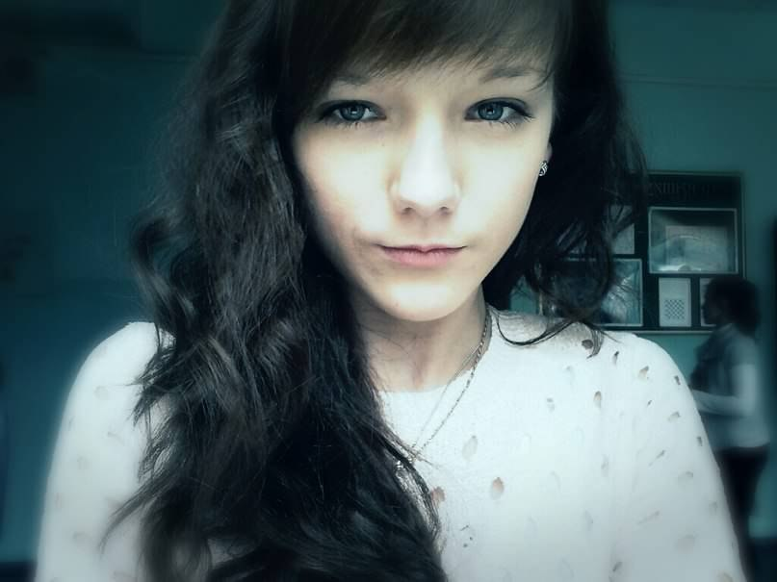
This is my brother and me in our childhood
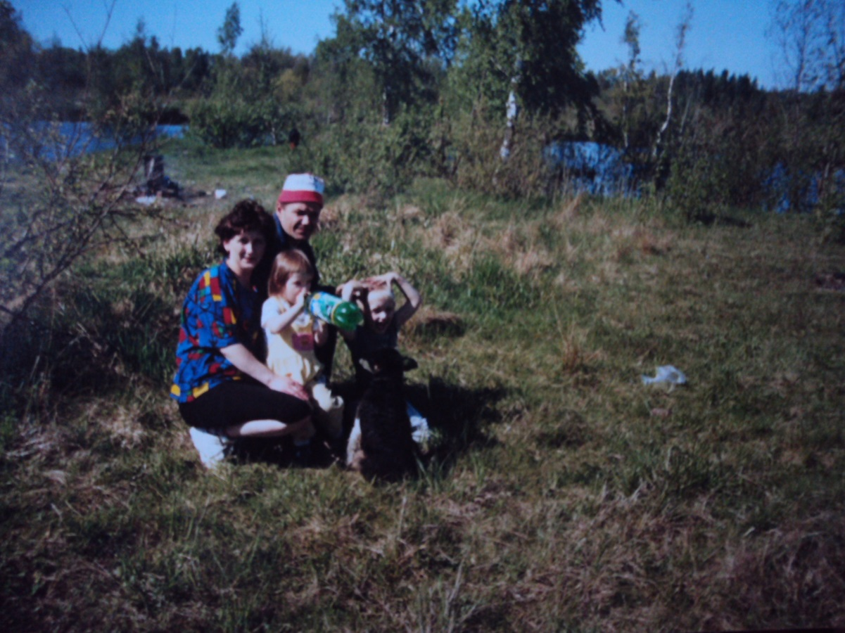
This is my favorite dog.
