My name is Leonid.

I was born on June 26, 1998 in St. Petersburg. I study at school №168 near Alexander Nevsky Monastery. I learn 2 foreign languages: German and English. I have 4 English lessons a week. My family is big. It consists of my father, mother, grandfather, grandmother, my brother, his family and me. I also have a pet. It’s a cat. His name is Barsik. I like to play with him. My father is a director of a company, my mother is his deputy. My brother works as a top manager in a big corporation. I have many hobbies. On weekends I and my family like to go fishing with my granddad. In my leisure time I like reading historical books, watching historical movies and I like swimming.
I live in the biggest city of North Europe - St.Petersburg. Since the day of foundation to the Great October Revolution it was a capital city. So,” North Venice” how many people call our city, is a cultural and historical centre of our country. If you come to our city, I’d like to recommend you the best places to visit. It’s the central part of the city, the Hermitage, the Mariinsky theatre and picturesque suburbs such as Peterhof and Pushkin. There summer residences of Russian monarchs are located.
I’m glad to participate in this project because I’m interested in the history and culture of your country and want to have friends from Denmark.

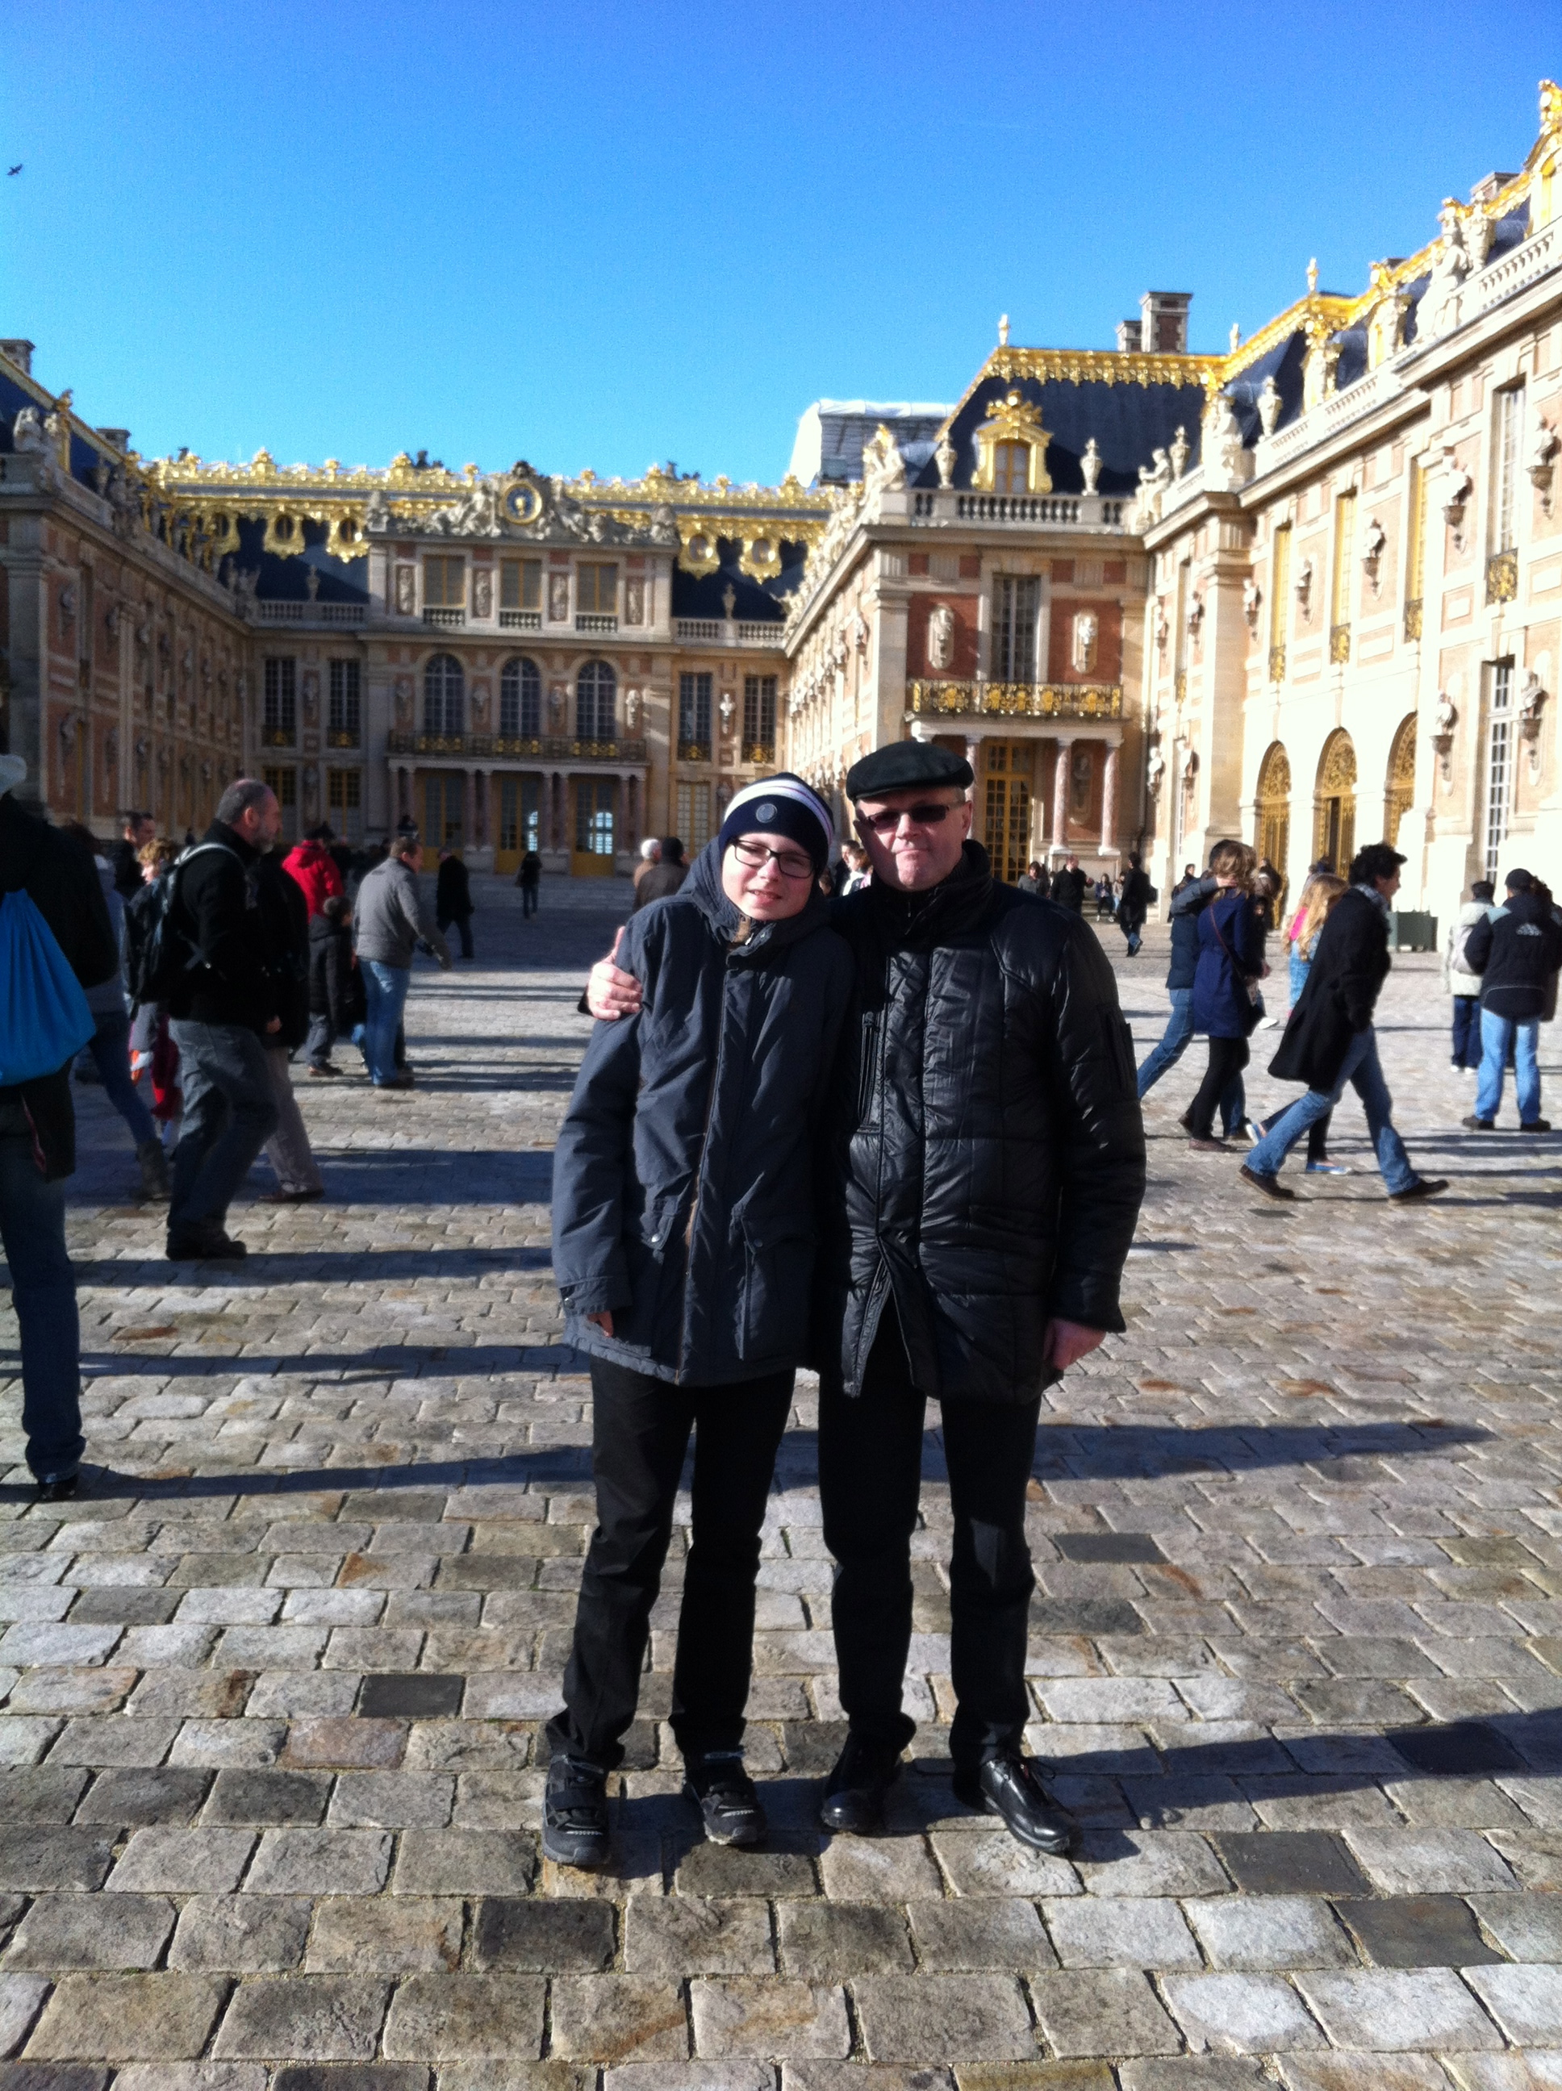

I’d like to invite you to the ‘’North Palmira” our beautiful city.

