Dear friend,
I live in Saint-Petersburg. I suppose it is one of the most beautiful cities because there are a lot of museums and real wonders like Petersburg’s nights. Best of all I like to go to the Russian museum because there are a lot of beautiful pictures .
My family isn’t large and it consists of my mother and me. My mother’s name is Lena. She is a tall woman with long fair hair and blue eyes. Her face is oval and her smile is nice. She is a clever and kind woman but sometimes strict. She works as a police officer. Her hobby is cross stiching. She cross stitches very well and there are more than 30 pictures at our home.
My name is Kirill. I learn in gymnasium N168 on the Nevsky Prospect. I’m a tall boy with short fair hair and blue eyes. My face is oval and my nose is straight. I’m kind and outgoing but a little lazy. I’m fond of walking. I go for a walk every day when I can. I walk around Saint-Petersburg with my friend and we discuss different films and books.
I and my mother do a lot of things together. We visited a lot of European countries, Cuba and Thailand.
We prefer to play volleyball and swim but we don’t like to visit different restaurants and museums. I and my mother have a lot in common but we have different views on my studying and tyding up.
I will be glad if you write about your family and hobbies.
Best wishes,
Kirill
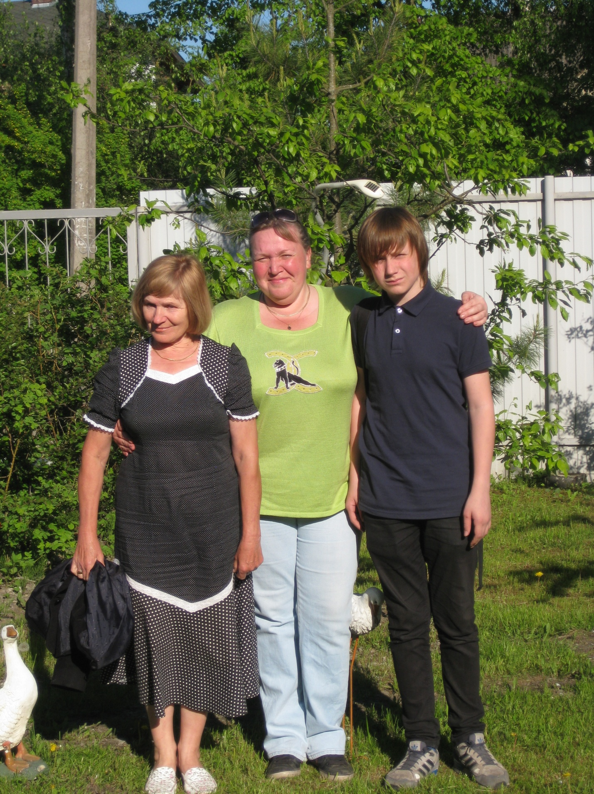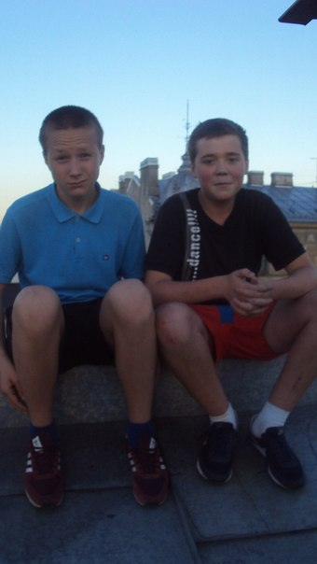
Photo 2011

